Expt 5 Design of High Pass Filter using Windowing Techniques
5.1 Generate the coefficients of an FIR High-Pass filter using Rectangular windowing techniques.
clc; clear; close all;
%% --- Input Parameters ---
fp = 1000; % High-pass cutoff frequency (Hz)
fs = 8000; % Sampling frequency (Hz)
N = 50; % Filter order

wc = fp/(fs/2); % Normalized cutoff (0–1)

%% --- 1. FIR High Pass using Rectangular Window ---
b_rect = fir1(N, wc, 'high', rectwin(N+1));
disp('--- High-Pass Coefficients (Rectangular Window) ---');
disp(b_rect');

%% --- 2. FIR High Pass using Hamming Window ---
b_hamm = fir1(N, wc, 'high', hamming(N+1));
disp('--- High-Pass Coefficients (Hamming Window) ---');
disp(b_hamm');
%% --- 3. FIR High Pass using Hanning Window ---
b_hann = fir1(N, wc, 'high', hanning(N+1));
disp('--- High-Pass Coefficients (Hanning Window) ---');
disp(b_hann');
%% --- Frequency Response Plots ---
figure;
freqz(b_rect,1);
title('High-pass FIR using Rectangular Window');
figure;
freqz(b_hamm,1);
title('High-pass FIR using Hamming Window');
figure;
freqz(b_hann,1);
title('High-pass FIR using Hanning Window');
OUTPUT:
High-Pass Coefficients (Rectangular Window) ---
-0.0089
0
0.0097
0.0143
0.0106
0
-0.0117
-0.0175
-0.0131
0
0.0148
0.0225
0.0171
0
-0.0202
-0.0314
-0.0247
0
0.0318
0.0524
0.0445
0
-0.0741
-0.1572
-0.2223
0.7407
-0.2223
-0.1572
-0.0741
0
0.0445
0.0524
0.0318
0
-0.0247
-0.0314
-0.0202
0
0.0171
0.0225
0.0148
0
-0.0131
-0.0175
-0.0117
0
0.0106
0.0143
0.0097
0
-0.0089
--- High-Pass Coefficients (Hamming Window) ---
-0.0007
0
0.0009
0.0016
0.0015
0
-0.0024
-0.0044
-0.0039
0
0.0060
0.0103
0.0088
0
-0.0128
-0.0217
-0.0184
0
0.0268
0.0464
0.0410
0
-0.0725
-0.1567
-0.2240
0.7493
-0.2240
-0.1567
-0.0725
0
0.0410
0.0464
0.0268
0
-0.0184
-0.0217
-0.0128
0
0.0088
0.0103
0.0060
0
-0.0039
-0.0044
-0.0024
0
0.0015
0.0016
0.0009
0
-0.0007
--- High-Pass Coefficients (Hanning Window) ---
-0.0000
0
0.0003
0.0008
0.0009
0
-0.0020
-0.0038
-0.0035
0
0.0057
0.0100
0.0087
0
-0.0127
-0.0216
-0.0183
0
0.0267
0.0464
0.0410
0
-0.0726
-0.1568
-0.2243
0.7500
-0.2243
-0.1568
-0.0726
0
0.0410
0.0464
0.0267
0
-0.0183
-0.0216
-0.0127
0
0.0087
0.0100
0.0057
0
-0.0035
-0.0038
-0.0020
0
0.0009
0.0008
0.0003
0
-0.0000
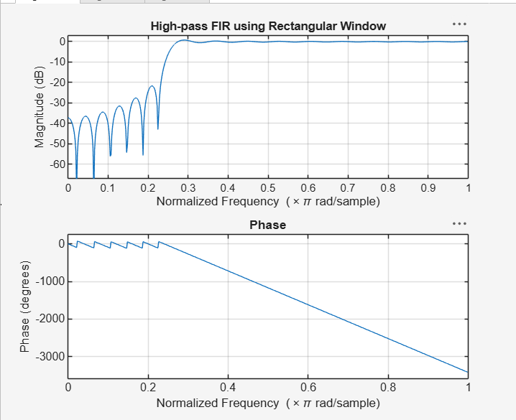
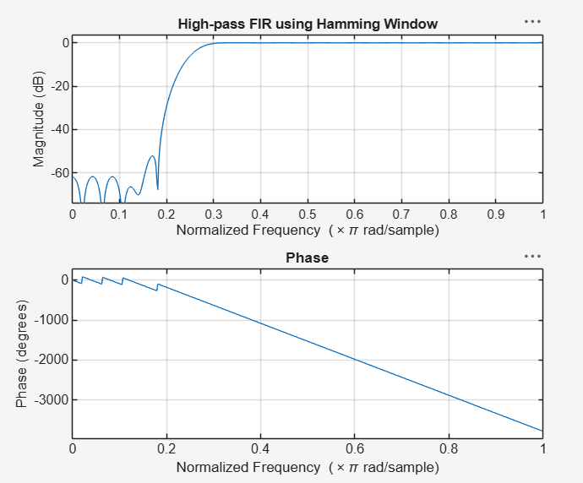
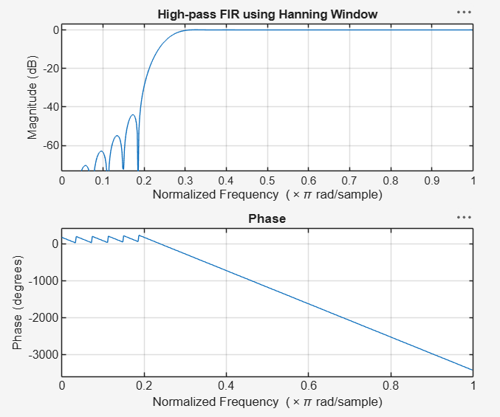

5.2. Generate the coefficients of an FIR High-Pass filter using Hamming windowing techniques
High-Pass Coefficients (Hamming Window) ---
-0.0007
0
0.0009
0.0016
0.0015
0
-0.0024
-0.0044
-0.0039
0
0.0060
0.0103
0.0088
0
-0.0128
-0.0217
-0.0184
0
0.0268
0.0464
0.0410
0
-0.0725
-0.1567
-0.2240
0.7493
-0.2240
-0.1567
-0.0725
0
0.0410
0.0464
0.0268
0
-0.0184
-0.0217
-0.0128
0
0.0088
0.0103
0.0060
0
-0.0039
-0.0044
-0.0024
0
0.0015
0.0016
0.0009
0
-0.0007
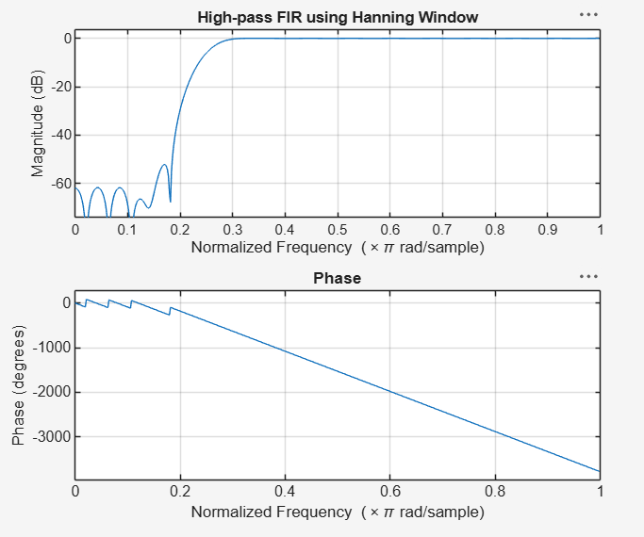
5.3. Generate the coefficients of an FIR High-Pass filter using Hanning windowing techniques
clc; clear; close all;

%% --- Input Parameters ---
fp = 1000; % High-pass cutoff frequency (Hz)
fs = 8000; % Sampling frequency (Hz)
N = 50; % Filter order

wc = fp/(fs/2); % Normalized cutoff (0–1)
%% --- FIR High Pass using Hanning Window ---

b_hann = fir1(N, wc, 'high', hanning(N+1));
disp('--- High-Pass Coefficients (Hanning Window) ---');
disp(b_hann');
%% --- Frequency Response Plots ---
figure;
freqz(b_hann,1);
title('High-pass FIR using Hanning Window');
OUTPUT:
- High-Pass Coefficients (Hanning Window) ---
-0.0000
0
0.0003
0.0008
0.0009
0
-0.0020
-0.0038
-0.0035
0
0.0057
0.0100
0.0087
0
-0.0127
-0.0216
-0.0183
0
0.0267
0.0464
0.0410
0
-0.0726
-0.1568
-0.2243
0.7500
-0.2243
-0.1568
-0.0726
0
0.0410
0.0464
0.0267
0
-0.0183
-0.0216
-0.0127
0
0.0087
0.0100
0.0057
0
-0.0035
-0.0038
-0.0020
0
0.0009
0.0008
0.0003
0
-0.0000
